ASSESSMENT CRITERIA 1- Cultural Relevance (40% Weighting)
Conformance with known cultural protocols associated with the Indigenous visual arts sector. This will involve a visual assessment of the artwork to determine if it conforms to known cultural protocols. In addition to this you will need to review the Cultural Justification provided within the Competition Entry Form and determine if the artist has adequately justified the relevance of their style to that of their own cultural heritage .
Assessment Criteria | Guidance | 1–2 (very low) | 3–4 (low) | 5–6 (medium) | 7–8 (high) | 9–10 (very high)
1.1 Cultural Integrity- Appropriation of Styles | Review the Australia Council for the Arts- Protocols for Producing Indigenous Visual Arts and other websites referenced within the Competition Design Brief. The artwork should not contain styles and motifs such as dot-painting, cross-hatching, X-Ray (showing of internal bone/organ structure), Bradshaw, Wandjinas, and more. | The artwork contains a very large percentage of Aboriginal art styles, symbolism and motifs commonly accepted as originating from outside of NSW. | The artwork contains a large percentage of Aboriginal art styles, symbolism and motifs commonly accepted as originating from outside of NSW. | Limited use of Aboriginal art styles, symbolism and motifs commonly accepted as originating from outside of NSW within the final artwork. | Very limited use of Aboriginal art styles, symbolism and motifs commonly accepted as originating from outside of NSW within the final artwork. | The use of Aboriginal art styles, symbolism and motifs commonly accepted as originating from outside of NSW is not present within the final artwork.
1.2 Conformance to Cultural Protocols | Guidance: Does the work reflect the cultural value of the subject matter? Is the artwork directly copied from known Aboriginal sites? Appropriation from styles within the local region is encouraged. Direct copying is not. Does the artwork expose confidential, personal or sensitive material? (Ie Men’s Business, Women’s Business)  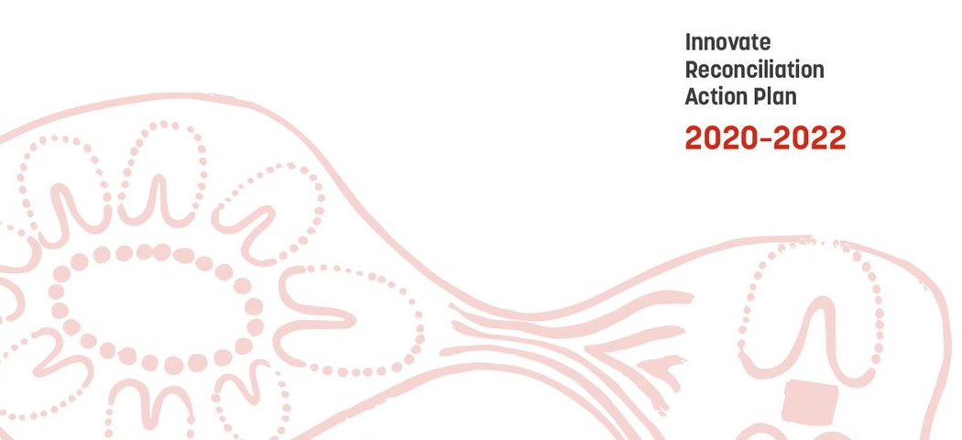 | The artwork itself is inclusive of a large volume of symbols, motifs and styles that are likely to offend some Aboriginal people due to it not conforming to known cultural protocols. | The artwork is inclusive of numerous symbols, motifs and styles that can be perceived as not conforming to known cultural protocols. | The artwork is inclusive of a limited range of symbols, motifs and styles that may be perceived as not conforming to known cultural protocols. | There are very limited aspects of the design that may be perceived as not conforming to known cultural protocols. | The artwork completely conforms to known cultural protocols.
1.3 Cultural Relevance | Aboriginal artists are encouraged to develop their own distinctive artistic expressions and draw on their particular cultural heritage. Does the artwork itself and the cultural justification within the Request for Proposal (RFP) show a clear link between the style and motif’s present and the artist’s cultural heritage? | Very limited reflection of cultural relevance within artwork and in cultural justification. Both illustrating a very limited link between the artist’s cultural heritage and the style and motifs present within the final artwork. | A limited reflection of cultural relevance within artwork and in cultural justification. Both displaying a limited link to the artist’s cultural heritage and the style and motifs present within the final artwork. | Culturally relevant artwork supported by cultural justification. Well-presented cultural justification that highlights a link to the artist’s cultural heritage and the style and motifs present within the final artwork. | Highly culturally relevant artwork supported by cultural justification. Detailed and well-presented cultural justification that demonstrates a considered reflection on the artist’s cultural heritage and the style and motifs present within the final artwork. | Extremely Highly culturally relevant artwork supported by cultural justification. The cultural justification is detailed and well-presented cultural justification that demonstrates a strong connection between the artist’s cultural heritage and the style and motifs present within the final artwork.
ASSESSMENT CRITERIA 2- ARTISTIC ABILITY (40% Weighting)
Demonstrated understanding, application and manipulation of visual communication language, elements and principles within artwork.
Assessment Criteria | Guidance | 1–2 (very low) | 3–4 (low) | 5–6 (medium) | 7–8 (high) | 9–10 (very high)
2.1 Ability to Use Design Principles to Convey Meaning | Has the artist incorporated key design principles into their artwork such as colour, space, texture, contrast, unity/harmony, balance, repetition and more. Do these principles simplify the conveying of concepts, ideas and observations present in their artwork story? | Very limited use and  manipulation of visual communication methods to convey concepts, ideas, and observations. | Limited use and manipulation of visual communication methods to convey concepts, ideas and observations. | Effective use and manipulation of visual communication methods to convey concepts, ideas and observations. | Skilled and effective use and manipulation of visual communication methods to convey concepts, ideas and observations. | Highly skilled and effective use and manipulation of visual communication methods to comprehensively convey concepts, ideas and observations.
2.2 Aesthetics of Artwork | Is the artwork aesthetically appealing? Has the artist incorporated key design principles into their artwork such as colour, space, texture, contrast, unity/harmony, balance, repetition and more. Would you purchase the art based on how it looks? | The artwork demonstrates a very limited understanding and use of visual communication methods, elements and principles. | The artwork demonstrates a limited understanding and use of visual communication methods, elements and principles. | Appropriate use of visual  communication techniques, elements and principles that reveals a satisfactory understanding and ability within the artwork. | Conceptually effective use of visual communication techniques, elements and principles that reveals a high level of understanding and ability within the artwork. | Insightful, conceptually  sophisticated and consistent  use of visual communication techniques, elements and principles that reveals a very high level of understanding and ability within the artwork.
ASSESSMENT CRITERIA 3- Artwork Story (20% Weighting)
Artwork Story- Resolution of ideas, directions and/or personal concepts within artwork. Review the artwork story provided with the Request for Proposal (RFP) Form.
Assessment Criteria | Guidance | 1–2 (very low) | 3–4 (low) | 5–6 (medium) | 7–8 (high) | 9–10 (very high)
3.1 Quality of Artwork Story | Is the art work story succinct and clearly articulated? Once reading it do you obtain a clear understanding of the message the artist wishes to tell? | Very limited reflection on artwork, displaying very  limited development and exploration of personal ideas, concepts and directions in working practices. | Some reflection on artwork, displaying limited development and exploration of personal ideas, concepts and directions in working practices. | Well-presented artwork story that highlights the progressive development and exploration of personal ideas, concepts and directions. | Innovative and well-presented  artwork story demonstrating a considered reflection on the progressive development and exploration of personal ideas, concepts and directions. | Highly innovative and well presented  artwork story demonstrating an insightful reflection on  the progressive development and exploration of personal ideas, concepts and directions.
3.2 Incorporation of Imaginative Thinking | Is the artwork theme imaginative and creative? Does it explore an issue that is outside of the box but equally as relevant to those that were proposed? | Very limited evidence of  resolution of thinking and working practices in the presentations of finished artwork. | Limited evidence of resolution of  thinking and working practices in  the presentation of finished artwork. | Evidence of some imaginative resolution of thinking and working practices in the presentation of finished artwork. | Evidence of imaginative resolution of thinking and working practices in the presentation of finished artwork. | Evidence of highly imaginative resolution of thinking and working practices in the presentations of finished artwork.
3.3 Justification of symbolism | From reading the artwork story do you get a clear understanding of the symbols, their meaning, their relationship to other symbols and their contribution to the overall message of the artwork? | Artwork story includes a very limited level of detail to justify symbolism inherent, resolution of ideas and directions. | Artwork story demonstrates a limited level of detail to justify symbolism inherent, resolution of ideas and directions. | Artwork story demonstrates a satisfactory level of detail to justify symbolism inherent, resolution of ideas and directions. | Artwork story demonstrates a high level of detail to justify symbolism inherent, resolution of ideas and directions. | Artwork story demonstrates a very high level of detail to justify symbolism inherent, resolution of ideas and directions.
3.4 Relevance of Artwork Theme | Is the artwork theme consistent with NSW Aboriginal culture and the local geographic region? | Artwork theme has very limited relevance to Aboriginal culture within NSW and the local geographic region. | Artwork theme has limited relevance to Aboriginal culture within NSW and the local geographic region. | Artwork theme demonstrates a satisfactory level of relevance to Aboriginal culture within NSW and the local geographic region. | Artwork theme demonstrates a high level of relevance to Aboriginal culture within NSW and the local geographic region. | Artwork theme demonstrates a very high level of relevance to Aboriginal culture within NSW and the local geographic region.

